Mathematical Conjecture

🌟 Definition
# Source: AI Source: Provided by: [Data Path: Persons Table -> ID Column: 1, Name_En Column: Motasem Essam] -> From: [ChatGPT] on [5/29/2026]
A mathematical conjecture is a statement that is believed to be true based on observation or patterns, but has not yet been proven or disproven.
It is an “educated guess” in mathematics that still requires a formal proof.

🎯 Purpose of a Conjecture
# Source: AI Source: Provided by: [Data Path: Persons Table -> ID Column: 1, Name_En Column: Motasem Essam] -> From: [ChatGPT] on [5/29/2026]
- To suggest possible mathematical truths
- To guide mathematical research
- To inspire the discovery of new theorems
- To explore patterns and relationships
- To challenge mathematicians to find proofs or counterexamples

📚 Key Characteristics
# Source: AI Source: Provided by: [Data Path: Persons Table -> ID Column: 1, Name_En Column: Motasem Essam] -> From: [ChatGPT] on [5/29/2026]
A mathematical conjecture is:
- Not proven yet
- Based on patterns or evidence
- Tested for many cases but not fully verified
- Either eventually proven (becomes a theorem) or disproven
- Important in advancing mathematics

🧩 Structure of a Conjecture
# Source: AI Source: Provided by: [Data Path: Persons Table -> ID Column: 1, Name_En Column: Motasem Essam] -> From: [ChatGPT] on [5/29/2026]
A conjecture usually has:
- A statement about mathematical objects
- Observed patterns or evidence supporting it
- No complete proof yet

✏️ Examples of Famous Conjectures

1. Goldbach’s Conjecture
# Source: AI Source: Provided by: [Data Path: Persons Table -> ID Column: 1, Name_En Column: Motasem Essam] -> From: [ChatGPT] on [5/29/2026]
Every even number greater than 2 can be written as the sum of two prime numbers.
Example:
- 10 = 3 + 7
- 16 = 5 + 11
(Still not proven)

2. Collatz Conjecture
# Source: AI Source: Provided by: [Data Path: Persons Table -> ID Column: 1, Name_En Column: Motasem Essam] -> From: [ChatGPT] on [5/29/2026]
Start with any positive integer:
- If even → divide by 2
- If odd → multiply by 3 and add 1
It is conjectured that this process always reaches 1.

3. Riemann Hypothesis
# Source: AI Source: Provided by: [Data Path: Persons Table -> ID Column: 1, Name_En Column: Motasem Essam] -> From: [ChatGPT] on [5/29/2026]
Concerns the distribution of prime numbers using the Riemann zeta function. It is one of the most famous unsolved problems in mathematics.

🔗 Relationship to Other Concepts
# Source: AI Source: Provided by: [Data Path: Persons Table -> ID Column: 1, Name_En Column: Motasem Essam] -> From: [ChatGPT] on [5/29/2026]
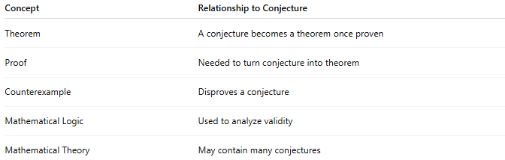
Concept | Relationship to Conjecture
Theorem | A conjecture becomes a theorem once proven
Proof | Needed to turn conjecture into theorem
Counterexample | Disproves a conjecture
Mathematical Logic | Used to analyze validity
Mathematical Theory | May contain many conjectures

📖 Conjecture vs Theorem
# Source: AI Source: Provided by: [Data Path: Persons Table -> ID Column: 1, Name_En Column: Motasem Essam] -> From: [ChatGPT] on [5/29/2026]
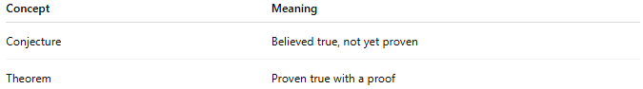
Concept | Meaning
Conjecture | Believed true, not yet proven
Theorem | Proven true with a proof
Example:
- Conjecture: “All even numbers are sum of two primes” (Goldbach)
- Theorem: “There are infinitely many prime numbers” (Euclid)

🧠 Simple Analogy
# Source: AI Source: Provided by: [Data Path: Persons Table -> ID Column: 1, Name_En Column: Motasem Essam] -> From: [ChatGPT] on [5/29/2026]
A mathematical conjecture is like a scientific hypothesis:
- Observation → pattern noticed
- Conjecture → proposed idea
- Proof → confirmation or rejection

🧭 Summary
# Source: AI Source: Provided by: [Data Path: Persons Table -> ID Column: 1, Name_En Column: Motasem Essam] -> From: [ChatGPT] on [5/29/2026]
A mathematical conjecture is a statement that seems true based on patterns or evidence but has not yet been proven. It becomes a theorem only after a correct mathematical proof is found.

